Date: Select a date

[NAME OF ORGANIZATION]
PROJECT TITLE
COUNTRY

PLEASE SUBMIT COMPLETED APPLICATION FORM AND ANY SUPPLEMENTARY DOCUMENTS TO opencall@common-fund.org

Common Fund for Commodities (CFC)

Mission
To contribute to poverty alleviation by strengthening the income-generating capacity of commodity producers and mitigating vulnerability to their economic well-being.

Vision
To strengthen and diversify the commodity sector in developing countries and transform it to be a major contributor to poverty alleviation and sustained economic growth and development.

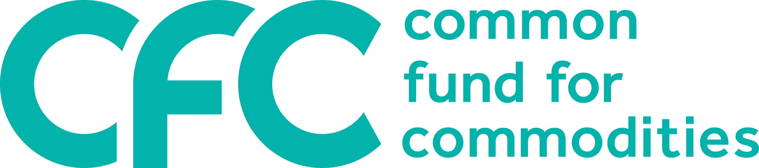

WHAT IS CFC LOOKING FOR? | The Common Fund for Commodities (CFC) is an international financial organization born out of the United Nations Conference on Trade and Development (UNCTAD) process in 1989. From its headquarters in Amsterdam, the Netherlands, CFC invests in the most vulnerable stakeholders of global commodity value chains, such as smallholders and SMEs to help them capture a greater share of the value they create in a sustainable way. CFC's ultimate goal is to catalyse innovative process of technology enabled structural transformations in global value chains to make them equitable and sustainable.  Do you believe that CFC funding can help you making your value chain shorter, greener and traceable, also including the application of technology, improvised or cutting edge digital technologies? Please fill in this application following the instructions provided therewith. The more innovative and impactful your idea is, the higher the chances that your proposal will receive CFC's funding to make a difference. Welcome to our shared journey of sustainability to achieve the sustainable development goals 2030.

PLEASE READ BEFORE COMPLETING THE FORM
NO FEES AT APPLICATION STAGE
CFC does not charge any fees during the application stage. However, on approval of CFC financing, applicants are expected to cover a fair share of the applicable legal and due diligence costs in connection with the applicability and use of the CFC financing.
COMPLETE AND ACCURATE INFORMATION IN THE APPLICATION
Please note that the CFC will only consider proposals providing reasonably accurate and complete information in the application form. An in-depth due diligence is part of CFC’s approval process.
CORRESPONDENCE ON SUITABLE PROPOSALS ONLY
The CFC will only contact you if your proposal is deemed suitable for further consideration. We regret that due to workload limitations the CFC is unable to respond to queries concerning individual applications. If you do not hear from us within 3 months after the deadline for submission, your application was not successful. You can, however, always re-apply in our next call for proposal if you prepare better.
EXCLUSION LIST
Please review the exclusion list for activities which are not eligible to receive CFC support. The list can be found on the CFC web site.
CONFIDENTIALITY NOTE
The information provided, including attachments, will be used to evaluate the request for financial support by the CFC, and may be shared with the CFC’s Consultative Committee, Executive Board, and the Governing Council.
If any of the documents contain sensitive financial or commercial information, please indicate this clearly.
PLEASE SUBMIT COMPLETED APPLICATION FORM AND ANY SUPPLEMENTARY DOCUMENTS TO opencall@common-fund.org
or by mail addressed to
the Managing Director,
Common Fund for Commodities,
P.O. Box 74656, 1070 BR, Amsterdam,
The Netherlands

PLEASE CHECK FOR THE DATES OF OUR WEBINARS ON CALL FOR PROPOSALS WHERE YOU CAN ANSWER ANY QUESTION THAT YOU MAY HAVE ABOUT YOUR APPLICATION. ALSO WATCH VIDEOS OF OUR EARLIER WEBINARS FOR A START.

Organization background

Organization profile
Summarize key activities (business model, products / services, industry experience, major achievements). Highlight main development impact of the organization.

Describe when and by whom the organization has been founded, if the organization belongs to a larger group, the key activities / products of the organization and markets relevant to it, and the historical milestones.

Location and target market(s)
The following countries are eligible for financing: Member Countries of the CFC
Describe organization premises, geographical location(s) of activities and development issues prevailing in those locations.

Brief summary of financing objectives
Summarize the funding demand, innovations and strategy behind the funding request, and main use of funds (e.g., expansion plans, working capital, trade finance or other).

Request for financing

Total financing need (project / investment cost) |  |  | EUR/USD
CFC financing requested: |  |  | EUR/USD
The loan amount requested from CFC should match with at least the same amount of co-financing provided by the applicant and/or by other defined co-financiers:

Name / amount of co-financer(s) |  |  | Co-financier 1 (name/amount)  Co-financier 2 (name/amount)
Financing can be provided in either USD or EUR. Depending on the form of financing required, please complete ONE of the 3 tables below (confirm by ☒): Please fill the relevant details in the table below.

- LOAN
Select type of loan | Amount (in EUR/USD) | Use of funds | Tenor | Collateral
☐ Trade finance | [Min 300,000, Max 2,000,000] |  | [Max 12 months], | [Confirm name/country of buyers]
☐ Working capital | [USD 300,000 - 2,000,000] |  | [Max 18 months] | [Describe proposed pledge or mortgage over assets or third-party guarantee]
☐ Term loan | [USD 300,000 - 2,000,000] |  | [Max 5 years, max 2 years grace period] | [Describe proposed pledge or mortgage over assets or third-party guarantee]
Note: The Trade finance and Working capital loan are annually renewable up to 5 years.
- EQUITY / Development Impact Bond
Select | Amount (in EUR/USD) | Ownership share | Use of funds
☐ Equity (investment funds only) | [USD 300,000 - 2,000,000] | [Max share of 49%]
☐ Development Impact bond (DIB) | [USD 300,000-2,000,000]

- FAST TRACK
Select | Amount (in EUR/USD) | Type of funding | Use of funds
☐ Fast-Track loan | [USD 50,000 - 300,000] | Provide repayment terms or provide rationale for requesting non-repayable funding.

Management and operations

Management and ownership
Main shareholders (in % of shares). Include a diagram of the structure of the organization (i.e., the holding entity or sister companies or subsidiaries (if applicable).
Summarize names / experience of (supervisory) board members, management team and other key staff (or attach in separate document).

Current business model
Describe current operations of the organization – i.e., what does it produce, process, trade in terms of (agri) commodities, in which countries, for which markets. Briefly describe different product lines. Describe existing facilities, operational process, staffing, sales/production volume, and production capacity.

Market opportunity

Market position and competitors
Describe the market opportunity and estimated market share (in %) of your organization. Comment on competitive environment and main competitors. Comment on key markets targeted and growth potential. Describe macroeconomic and policy environment if relevant to the project, sector, or country.

Key strength of your business model
Describe the opportunity that the project would develop. What is unique about your proposition in comparison with the competition. What are the top reasons why the CFC should support the application?

Obstacles
Identify key obstacles and how these would be addressed by the project. If necessary, refer to Section 7.4 “Risks”.

Proposed operational model

Proposed business model
Describe how the CFC financing will be used to improve products/services, operations, sales/production volumes, production capacity, and supply/offtake model etc (where relevant).

Client base and growth potential
Describe the key buyers / customers of the organization and main distribution channels (where relevant). Describe the offtake agreements (price setting arrangements, currency, etc.).

Supply
Describe key products supplied to the organization, how and by whom these are supplied and type of agreements (i.e., seasonal, or long-term, price setting arrangements, etc.). If supply comes from smallholders, highlight how smallholders are engaged and organized.

Production process
Describe value addition through the proposed operation, including any need for equipment, staff, skill development, digitalisation, or changes to the current operation.

Innovation
What innovation your business model wishes to implement? How that innovation may help you to make the value chain greener, shorter, and traceable?

Development impact
For details of development impact indicators, please refer to the model excel spreadsheet downloadable with the application form.

Targeted impact, innovation, and additionality
Describe what innovation will be made possible with CFC financing. Explain what development impact will be achieved, highlighting how the impact will be sustainable.

Impact on Sustainable Development Goals (SDGs)
Describe how CFC financing will contribute to the SDGs, with emphasis on the five core CFC SDGs. Please fill out the summary table below and provide the specific impact indicators and projected impact in the Excel document attached to this form. Please bear in mind that impact must be evaluated in the context of the baseline situation.
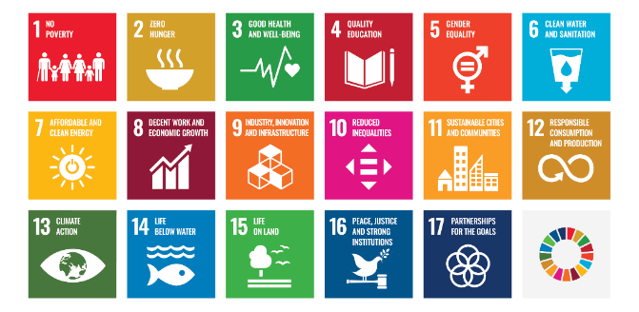
The 17 UN Sustainable Development Goals:
SDG | Expected impact
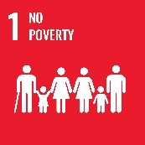
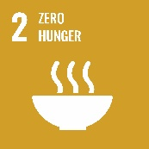
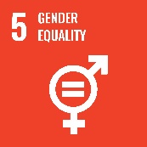
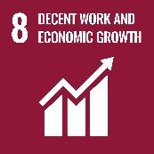
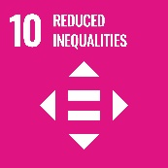
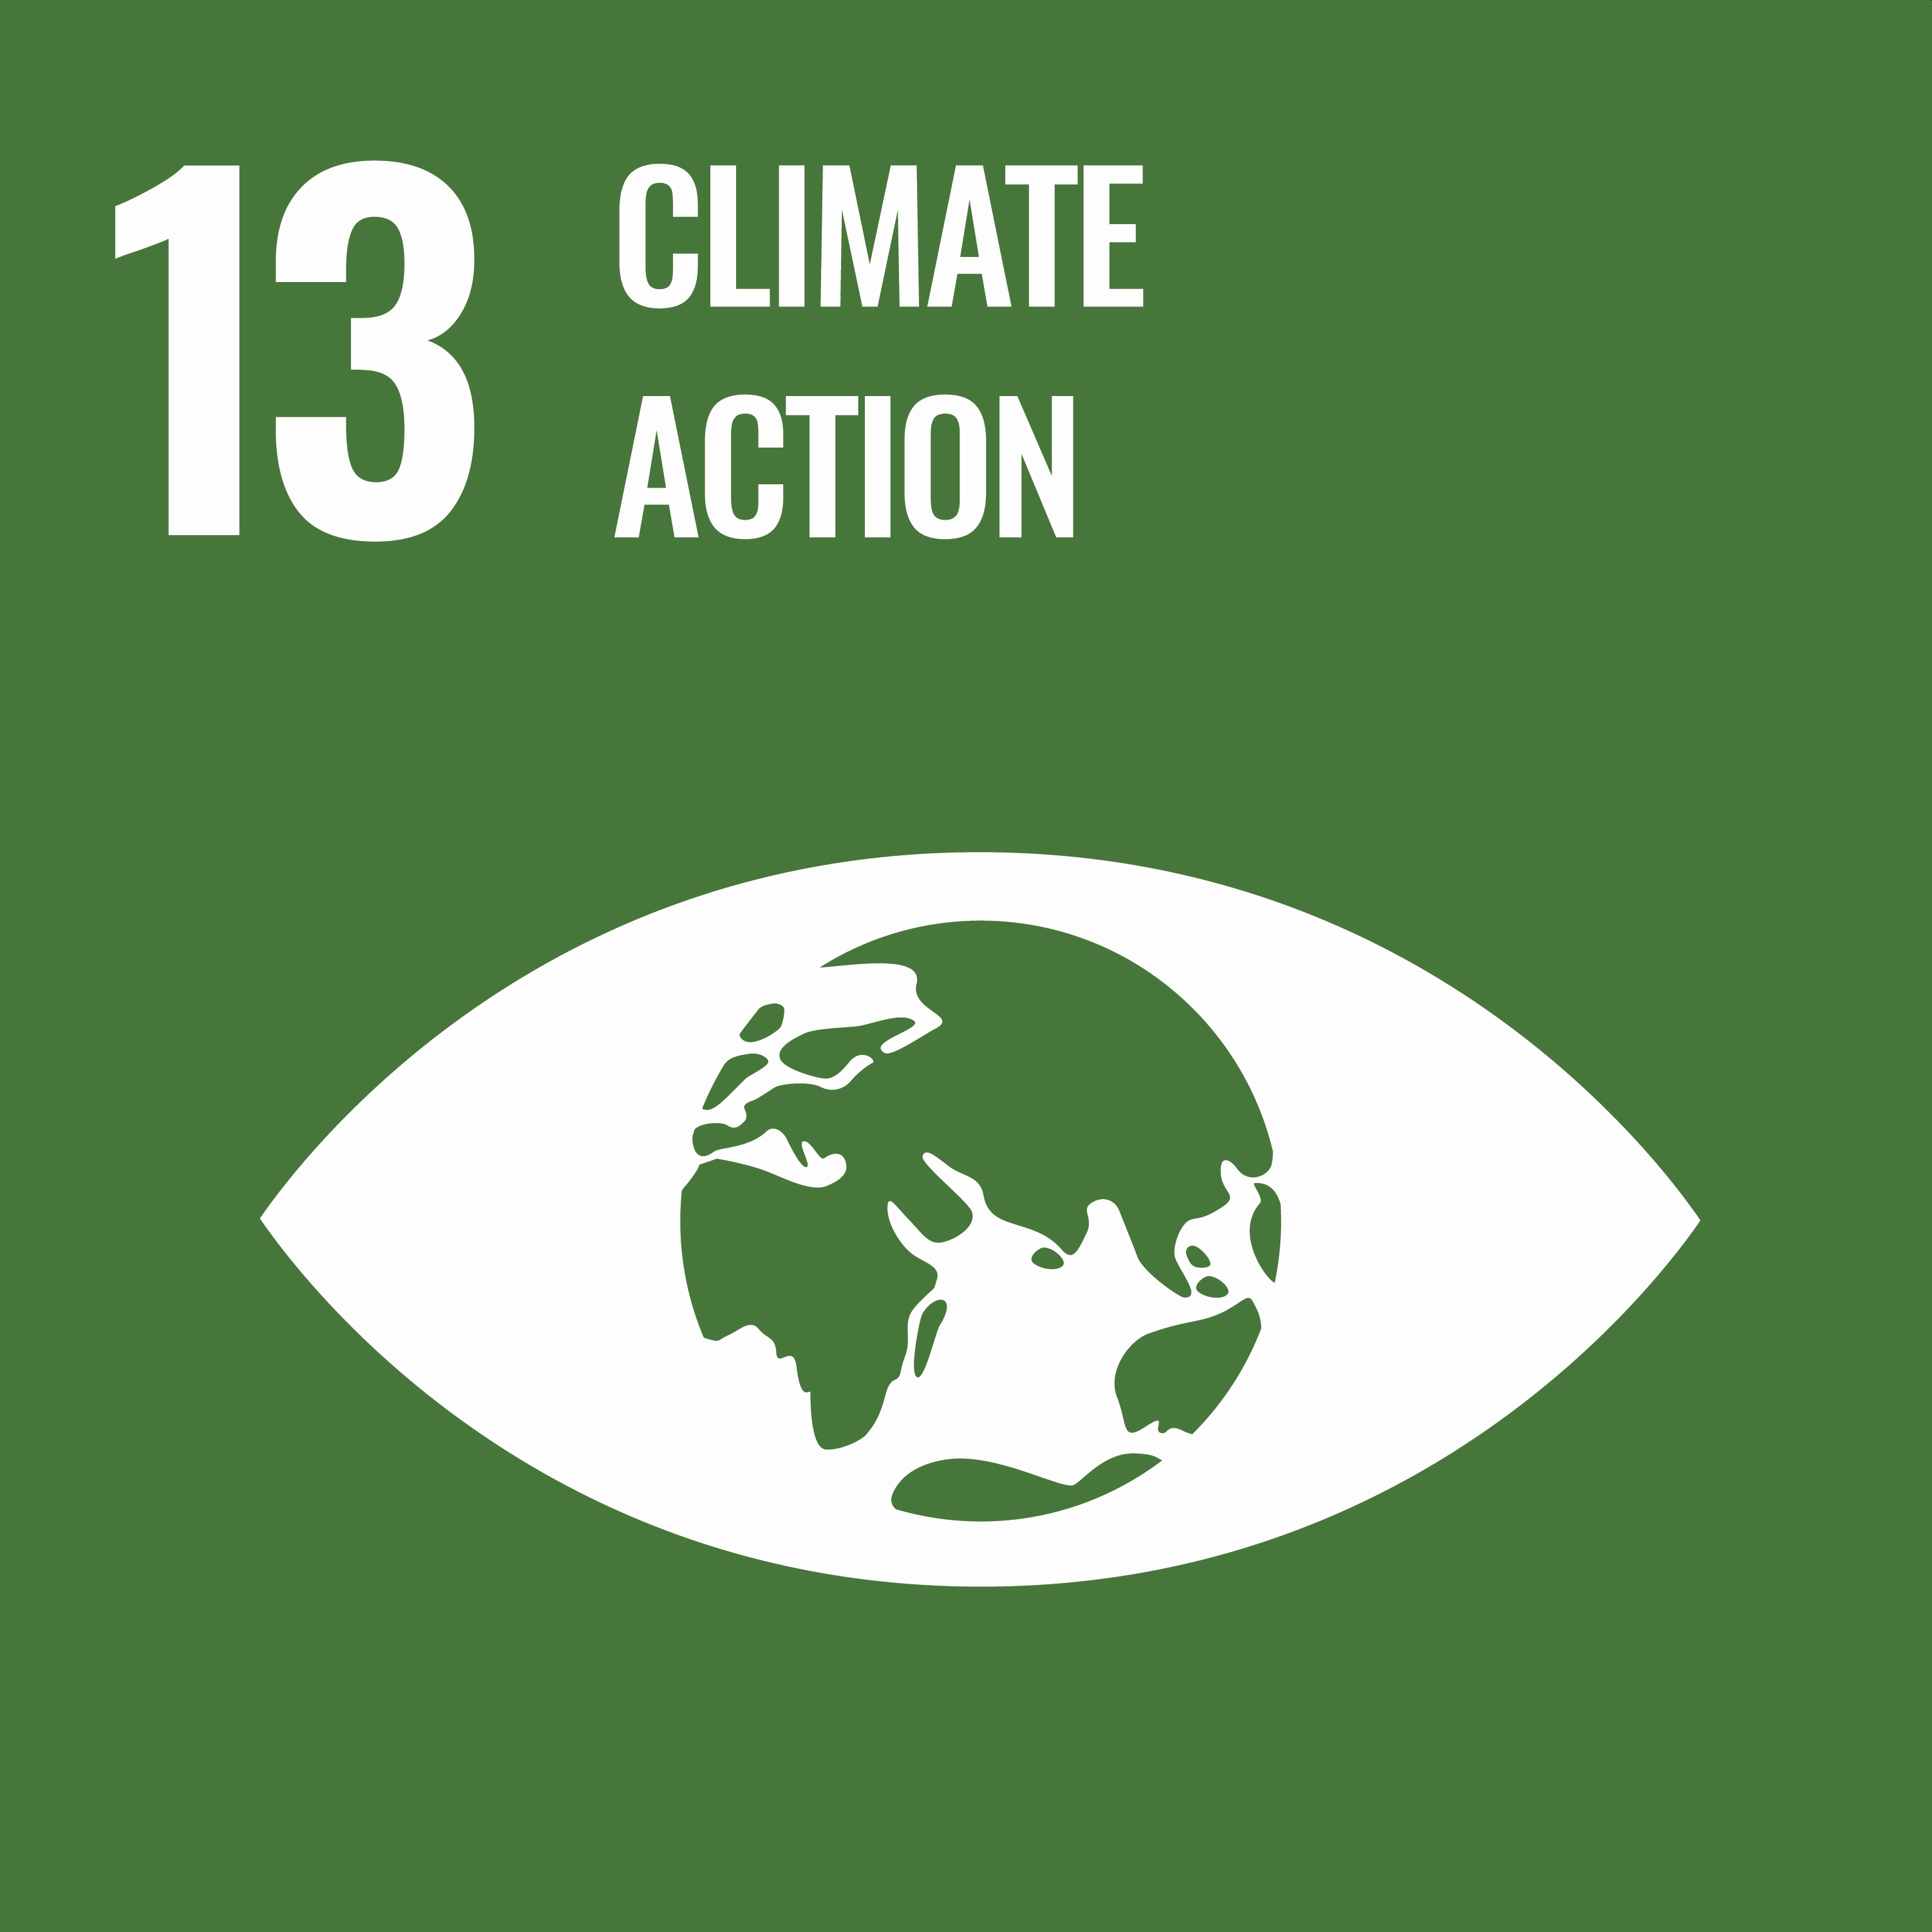
SDG [enter number]

Poverty profile of end beneficiary
Please provide any specific indicators of poverty prevalence among the target beneficiaries (e.g., smallholders, migrant workers, other vulnerable groups) in the regional context.

Social and Environmental risks
Describe key social and environmental risks related to the project or the sector in general and explain how these are being managed. Examples of such risks might include poor working conditions, use of hazardous substances, weak waste management systems, set-up of new plantations.

Financial performance

Historical financial statements
Comment on main revenue / income drivers and financial standing over the last financial year(s).

Financial projections
Please fill out your own financial projections in the Excel sheet provided with the form. Make sure to explain the main assumptions of financial projections, e.g.:
- Assumption 1: (e.g.: Volume growth (in kg/MT) for product X from . to ..
- Assumption 2: (e.g.: Sales price/kg to increase/decrease by ..)
- Assumption 3: ...
- Assumption 4: …

Sources of funding and additionality CFC
Confirm names of existing financiers and type of facility / amount and explain the challenges to the feasibility of the project in the absence of CFC involvement.

Main risks and mitigants
Please evaluate the impact of main risks on the business case and your proposed mitigation measures.
Risk/impact description | Likelihood | Mitigation measures
 | Select level
 | Select level
 | Select level

Supporting document checklist

Required documents (confirm by ☒):
☐ Audited financial statements (latest 3 financial years)
☐ Financial projections including Balance Sheet and Profit & Loss forecast
☐ Impact indicators (please fill out the template excel spreadsheet)
☐ Company registration documents
☐ Legal ownership chart for all entities of the group (in case of several legal entities)

Recommended supplementary documents (not mandatory in this stage)
☐ Business plan
☐ Management / Organization chart
☐ Key staff resume/s
☐ Articles of Association
☐ Environmental & Social Impact Assessment (ESIA)

Key details

Name of organization

Type of organization | [private company, cooperative, investment fund, NGO, governmental organization]
Country of incorporation
Date registered
Company registration number
Address
Website

Affirmations
The application is completed by the undersigned:

Contact details
Name
Title
Phone
Email

I hereby confirm that: (confirm by ☒):
☐ I am duly authorized to represent the Organization:
☐ The country in which the funds are used are to take place in a CFC member country.
☐ The Applicant observes the principles of UN Global Compact, including universal principles on human rights, labour, environment, and anti-corruption. The Applicant is in compliance with all applicable social and environmental regulations and will remain complaint for the whole period of the requested CFC involvement.
☐ The Applicant is not the subject of a defendant in, or respondent to any investigation, civil litigation, arbitration, or other action or proceedings related to their business activities. I will inform the CFC without delay if any such action or proceedings occur after the date of submission of this application.
☐ I warrant that the information provided in this application form is true and accurate.
☐ I understand that any information supplied to the CFC in this application form and its attachments will be made available for consideration by the Consultative Committee and other Governing Bodies of the CFC. If any of the documents contain sensitive financial or commercial information, please indicate this clearly.

How did you find out about the CFC call for proposals?

Advertisement – please name the publication
Web search (e.g., Google)
Social Media (e.g. LinkedIn)
Any other – please specify

Loan disbursement is based on sales contracts from eligible buyers, agreeing to make full payment directly into the account of the CFC.
Equity stakes in impact investment funds only. CFC does not directly invest into businesses.
The CFC supported the first Development Impact Bond in the commodity sector and will consider participating as investor in projects financed under DIB model. For details, see Development impact bonds: learning from the Asháninka cocoa and coffee case in Peru (practicalactionpublishing.com) (DOI: 10.3362/1755-1986.16-00029)
Fast Track financing refers to a simplified approval procedure for projects seeking financial support below USD300,000. It is envisaged for selected activities yielding immediate results towards CFC objectives and/or the development of innovative products and services in a precommercial phase.
For more information on UN Sustainable Development Goals please refer to UN web page THE 17 GOALS | Sustainable Development (un.org)
See for the actual list of CFC member countries www.common-fund.org/ about-us/member-states/.

